

OFFICE OF THE

**Vice PresidentStudent Life**

**Date:** 04/05/2021

**To:** Students’ Union Council

**Re:** Vice President Student Life 2021/22 Report #1

Dear Council,

Happy first Council meeting! I know Council can be intimidating at first and it can be hard to feel like you belong here, but just remember that you were elected by students who believe in you and you deserve to be here! I am so excited to learn from and work with each of you. If you ever need help with anything please feel free to reach out.

Yesterday was our first official day in office, but for weeks now I have been working with the rest of my team to learn all about our new positions and develop the skills I need to hit the ground running. In April I had weekly transition meetings with Katie, attended all the meetings I would need to attend as VP Student Life, and got to know all of the folks I will be working closely with this year. Last week we had retreat which allowed me to deepen my understanding of this role. I am very excited to get started on all my projects.

VP Kimani and I have already started working on two of our joint projects, the Period Poverty initiative, and the EDI Task Force. For the Period Poverty initiative, we’ve started creating a detailed plan for how we are going to make this project financially sustainable for the environment. For the EDI Task Force, we’ve started getting our ‘ducks in a row’ by creating preliminary plans for what projects the committee can take on this year. Other than these two projects, I have been developing plans and meeting with staff to get started on the projects outlined in my platform.

If you have any questions about any of this please let me know, this report is shorter than most and in the future ones, I will provide many more updates!

I also want to make sure that these reports are not super boring and that there’s something fun at the end for those who read the whole report. So this year I've decided to give self-care tips every week that have helped me prevent burnout. This week I went for a hike at Elk Island. The hike I did was called Wood Bison Trail #11 and it was four hours but it was super easy, I saw a bison, a moose (and her baby), a bunch of very cool birds, and mushrooms. For me going on a hike is ideal self-care because it's something that I love to do, it lets me relax without looking at a screen, and it allows me to get active. So my self-care tip is to go for a hike! If you’re not an experienced hiker you should try Wood Bison Trail #11.

Here's a picture from the trail!

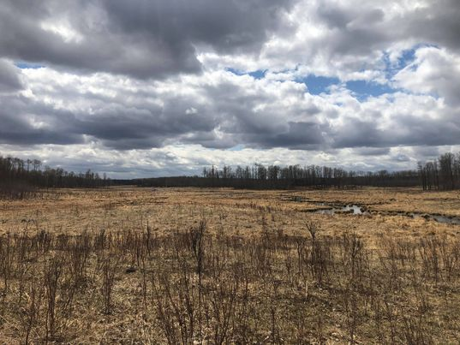

Best,

Talia Dixon

**Talia Dixon**

University of Alberta Students’ Union Vice President Student Life

**Talia Dixon, Vice President Student Life**

2-900 SUB | 780 492 4241 | talia.dixon[@su.ualberta.ca](mailto:vp.finance@su.ualberta.ca)