**Date**: 09/06/2022

**To**: Students’ Union Council

**Re**: Vice President Academic 2022/23 Report #9

Dear Council,

Hope you are settling well with your classes and had fun at the Week of Welcome!

I want to start this report with something very interesting. 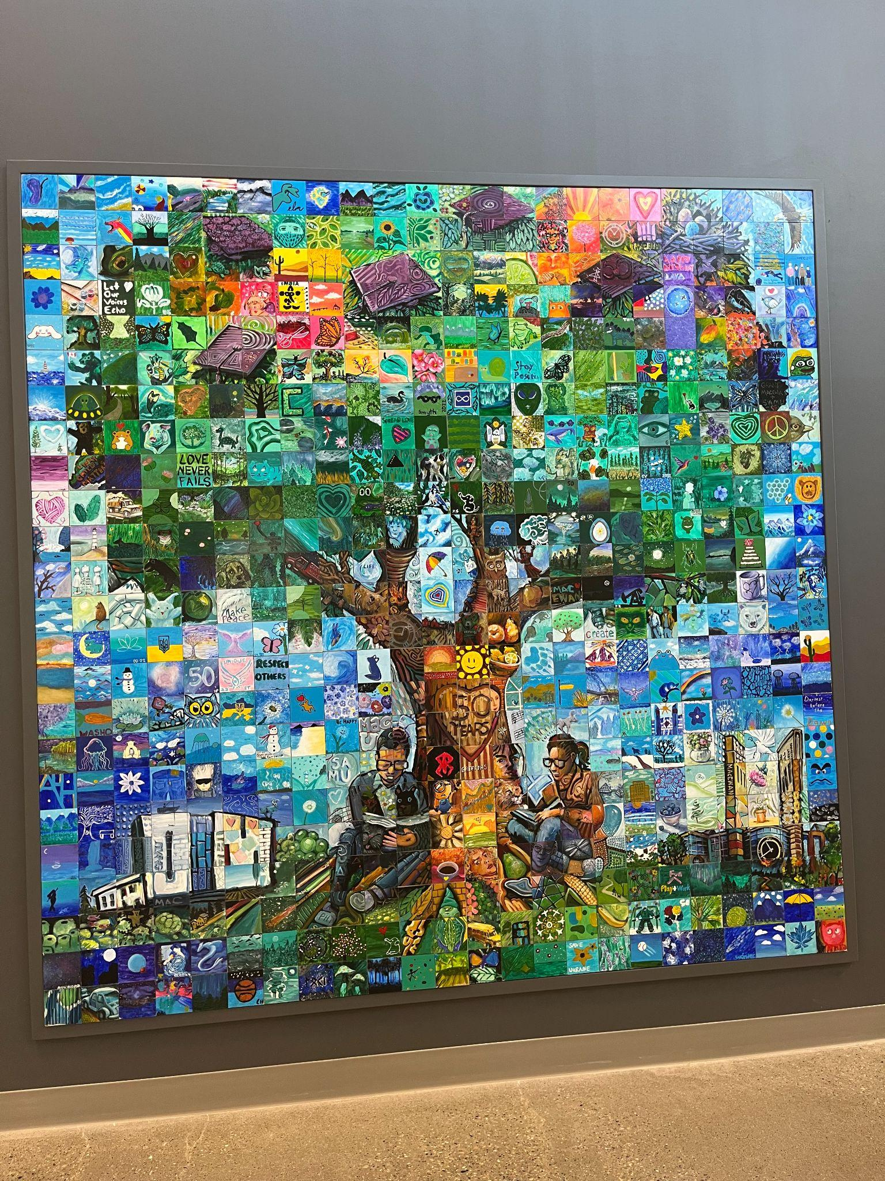

**Cool Artwork at SAMU (Students’ Association of MacEwan University)**

This is a huge artwork in the SAMU building. It looks like one big painting but when we look at it closely, it is made of 576 small tiles belonging to a different individual. I don’t know how they coordinated it but it is extremely fascinating and beautiful. A perfect piece of ‘diversity coming together but not giving up rather holding onto their uniqueness’. I believe each picture, each artwork in the world tells millions of stories. Each and every one from the audience would receive a different story depending on their place(part) in the world and their character that they are ought to play on the stage(world). Spend some time with this piece and find out what story it has for you :)

**CAUS Counterparts**

Last weekend of September, we were in Lethbridge for the CAUS (Council of Alberta University Students) Counterparts Conference. It was a good opportunity to meet our counterparts from different Alberta schools so I had a good time discussing some goals and ideas with other VPAs.

**GFC**

Me and President Monteiro had a meeting with Kate Peters (GFC Secretary and Manager of GFC Services) and Faiza Billo ( Governance Systems Coordinator) to discuss our priorities at GFC. We have decided that they will be joining us at the GFC Caucus this time to provide an orientation to the GFC Student representatives and address the questions that the students may have about GFC.

Meetings for GFC Standing Committees have started, I had the GFC Nominating Committee last week and some others are scheduled for the coming weeks.

**URI (Undergraduate Research Initiative)**

I had a meeting with the URI and we discussed the ideas to make URI more accessible to students and spread awareness about it. I will be sharing more as we move forward.

**U of C Presentation**

Me and VP Ops Fi Villoso gave a presentation about the Students’ Union at the orientation for Edmonton based University of Calgary students.

**SAMU Visit**

As you have seen the artwork above, I was given a tour of the building by SAMU VPA Stephan Vasquez. We also discussed some interesting approaches to Academic Integrity Policy. Right now, I am working on figuring out similar ways that could be adopted according to the needs of our university which I found valuable in their mechanism.

**CoFA**

CoFA Senior Board met. I was able to get two people who are interested for the Sustainability and Capital Fund Committee (SCFC) as we have 2 CoFA seats on it. Also the preparations for the SRA Summit are on the ground.

**Student Issues**

This is the part that I felt very satisfying when I was able to help students who were worried and were facing troubles. I helped some students through the registration problems that they were facing. For instance, I was able to help an international transfer student get approval from the Registrar’s Office to remain at the U of A after a problem with their transcripts.

**International Students’ Orientation**

I attended the ISA Orientation where I got a chance to speak to new International Students’ which was really fun, especially seeing their enthusiasm. Also talked to the University of Alberta International (UAI) and they shared some important concerns with me which I will be bringing up with the university.

**WOW**

Lastly, I attended some really fun activities at the Week of Welcome and the experience of meeting new students and talking to them was really rewarding.

There was a lot for this report so I tried to touch on all the important updates briefly. Please reach out to me if you are interested in any details, always happy to chat :)

Take care friends!

Best wishes,

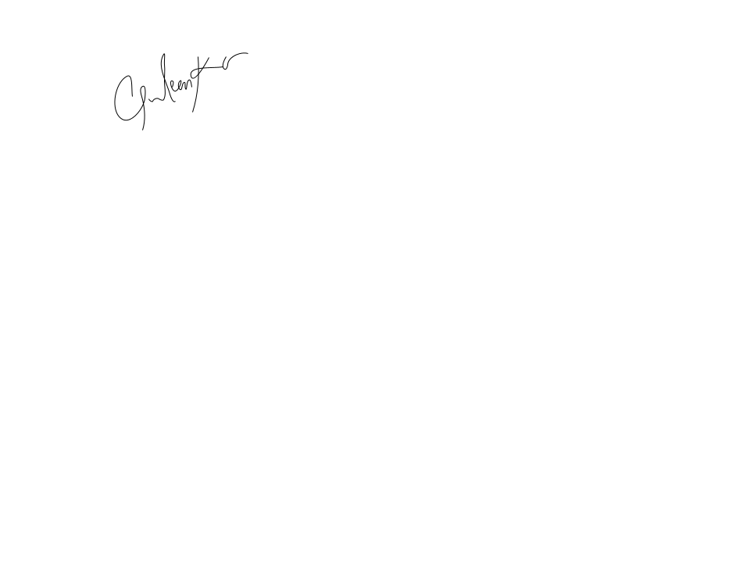

**Gurleen Kaur**

Vice President Academic

University of Alberta Students’ Union