**Date**: 09/20/2022

**To**: Students’ Union Council

**Re**: Vice President Academic 2022/23 Report #10

Dear Council,

Here are some updates from previous weeks.

**Registrar’s Office**

Last week, the executive team had a meeting with the Registrar’s Office. We gave a presentation on our goals for the year and also talked about some specific projects that we are working on.

I have also been reaching out to individuals from the RO and working with them on different areas, for instance, ZTC.

**GFC**

I had the GFC Exec committee and GFC programs committee meetings. We also had the GFC caucus meeting where University governance staff gave an orientation to the GFC student representatives and addressed their concerns.

The main items on the GFC agenda this time are Sexual Violence Policy revisions and Exploration Credits. I have been getting questions regarding the latter. The latest update for that is, the university is making some policy changes and working towards setting some standards for exemption of courses from being available for exploration credits. The reason behind this is that some faculties were asking for large exemptions which reduces options for the students. So, the discussion has been made that the faculties would need the approval of the Programs Committee for getting any exemptions. More information will be available [here](https://www.ualberta.ca/registrar/registration-and-courses/special-registrations/exploration-credits/index.html) .

**SRA Summit**

President Monteiro, VPSL Fogue and myself, have been working on the SRA Summit. We got the registration form filled by all the SRAs and currently, we are finalizing the sessions for the summit according to the topics of interest indicated by folks in their registration form. There is almost a month left until the summit, so all the preparations are on the way.

**Council committees**

AS a part of the **Policy committee**, we have started the consultation processes for the policies which are expiring this year. We have shared the tuition policy draft with CoFA members to get their feedback. The **Student Group committee** had its first meeting and Councillor Jayden Brooks was appointed as the chair of the committee. I want to congratulate him and I look forward to working on this committee. To fill the CoFA seats at **SCFC** (Sustainability and Capital Fund Committee), 2 CoFA members have been appointed by the Exec Committee.

**Vice- Provosts**

I had my monthly meeting with the vice-provosts. We discussed embedded certificates and I raised student concerns and they promised to look into them. Also, in collaboration with the Provost’s Office, we will be running a survey on embedded certificates through Perks to get more feedback from students in order to work towards making the certificates more accessible and standardized.

**COSA**

I attended the Council on Student Affairs (COSA) meeting on behalf of President Monteiro. There was a good conversation on the ‘Student Accessibility' piece. The Student Accessibility Project Report that was shared for COSA members can be found [here](https://www.ualberta.ca/governance/media-library/documents/member-zone/gfc-standing-committees/cosa-meeting-materials/item-8-student-accessibility-assessment-project-report.pdf). I invited Hussain Alhussainy, GFC Arts representative to share student concerns related to accessibility at the meeting. He shared some very important and valuable points coming from students’ voices, which I felt was absolutely important for guiding the upcoming steps towards accessibility.

Lastly, CoFA meetings for the month are coming up this week and I’m taking care of individual student issues as I mentioned in my previous report.

Let me know if you have any questions and take care :)

Best wishes,

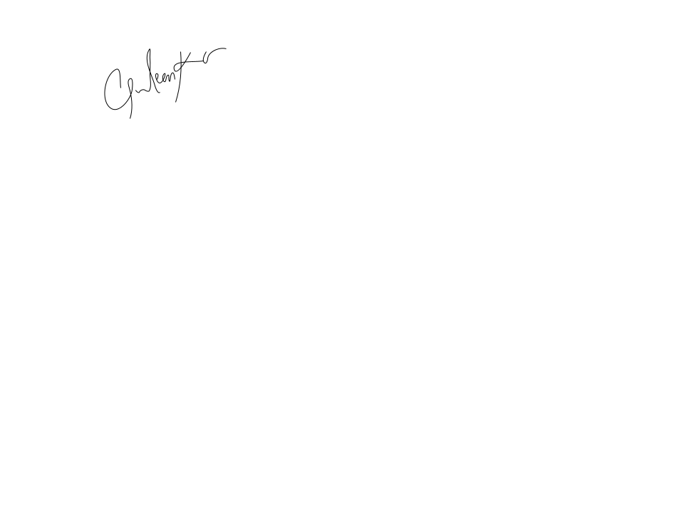

**Gurleen Kaur**

Vice President Academic

University of Alberta Students’ Union