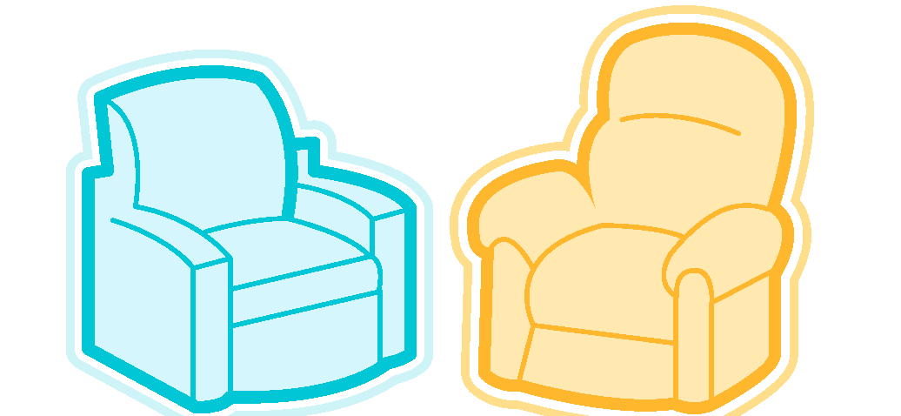

Peer Support Centre

Volunteer Application Form

Please fill out this form and return it to the Peer Support Centre (by email or drop off at the centre, located at 2-707 SUB). The deadline for applications is August 16th, 2013 however, since spots fill up quickly, it is recommended that you hand in your application as soon as possible. Thank you for your interest in volunteering with us!

Our mandatory training is tentatively scheduled for the end of August/beginning of September. Training is 30 hours and specific dates will be finalized by the end of June. As training dates are still tentative, please indicate the following in order to help us select times:

My preference is to train during: <INPUT TYPE=\Evenings & Weekends (spanning from August 24-September 7)
<INPUT TYPE=\Weekdays (9-5pm) (spanning from August 19-August 30)
Based on my availability I can attend: <INPUT TYPE=\Evenings & Weekends (spanning from August 24-September 7)
<INPUT TYPE=\Weekdays (9-5pm) (spanning from August 19-August 30)

All dates and times are mandatory. A lot of material is covered so we are unable to accept applicants who cannot attend all sessions in full.

Date: ________________________

Name: _________________________________________________ Student ID:_____________________
First Last

Faculty & Program ______________Current Year of Program: _____Graduation Year (if applicable): _____

Current Address: ______________________________ Postal Code: ___________

Telephone: Home: ___________Hours to Call: _________Cell: __________ Hours to Call: _________

Are you a student at the University of Alberta? Yes<INPUT TYPE=\ No <INPUT TYPE=\
Top of Form
Are you 18 or over? Yes<INPUT TYPE=\ No <INPUT TYPE=\

How did you learn about our volunteer recruitment?
<INPUT TYPE=\ Classroom presentation <INPUT TYPE=\ Word of mouth <INPUT TYPE=\ Poster/billboard <INPUT TYPE=\ Other :______________

Have you previously volunteered with the Peer Support Centre?
Yes <INPUT TYPE=\ No <INPUT TYPE=\ If yes, when? ______________________________

Have you previously applied and/or interviewed with the Peer Support Centre?
Yes <INPUT TYPE=\ No <INPUT TYPE=\ If yes, when? ______________________________

Have you volunteered previously with any other supportive listening agency?
Yes <INPUT TYPE=\ No <INPUT TYPE=\ If yes, when and with which agency?
_______________________________________________________________________________

Volunteer Experience

Date Organization Position
______________ ________________________ _______________________________________
______________ ________________________ _______________________________________
______________ ________________________ _______________________________________

Work Experience

Date Organization Position
______________ ________________________ _______________________________________
______________ ________________________ _______________________________________
______________ ________________________ _______________________________________

Please list any specialized courses/training you think would be applicable:

What other major time commitments do you have? (How many classes, job, other volunteer positions?)
____________________________________________________________________________________________________________________________________________________________________________

Other relevant skills or experiences: ____________________________________________________________________________________________________________________________________________________________________________

Please explain your reasons for wanting to volunteer with the Peer Support Centre. What do you hope to get from your experience? What qualities and skills will you bring the service?

____________________________________________________________________________________________________________________________________________________________________________________________________________________________________________________________________________________________________________________________________________________________________________________________

When you think of the following issues, what major feelings come to mind for you? These can include your own reactions, or how you would imagine someone experiencing these situations might feel. Please note that there are no right or wrong feelings. Please list 3-5 feelings for each.

Family Violence: _____________________________________________________________________

Suicide: ___________________________________________________________________________

Sexual Assault: _____________________________________________________________________

Child Abuse: ________________________________________________________________________

Substance Abuse:____________________________________________________________________

Mental Illness: ______________________________________________________________________

Abortion: ___________________________________________________________________________

Homosexuality: ______________________________________________________________________
The following factors need to be considered when applying to volunteer with the Peer Support Centre. Again, there is no right or wrong answer; we are simply interested in your experience with difficult life circumstances. Please answer yes or no to each question below:

I have experienced a major loss or life event in the last year.
Yes <INPUT TYPE=\ No <INPUT TYPE=\
If yes, describe briefly:___________________________

I have a health condition that can be made worse with stress.
Yes <INPUT TYPE=\ No <INPUT TYPE=\
If yes, describe briefly_____________________________________

I have attempted suicide in the past.
Yes<INPUT TYPE=\ No <INPUT TYPE=\
If yes, when? _________________________________________

I have lost someone close to me to suicide.
Yes <INPUT TYPE=\ No <INPUT TYPE=\
If yes, when? ___________________ Relationship: __________________

I can understand that someone may feel suicidal when the pain they are experiencing becomes overwhelming
Yes <INPUT TYPE=\ No <INPUT TYPE=\
If no, or uncertain, please elaborate:____________________________________________________

I am currently seeking mental health care.
Yes <INPUT TYPE=\ No<INPUT TYPE=\

I am comfortable/willing to provide referrals and information on abortion upon client request
Yes<INPUT TYPE=\ No<INPUT TYPE=\

I have been convicted of an indictable offense.
Yes <INPUT TYPE=\ No<INPUT TYPE=\
If yes, what offense and when? _________________________

I am willing to submit to a criminal record check.
Yes<INPUT TYPE=\ No<INPUT TYPE=\

I am willing to volunteer with the Peer Support Centre for at least one academic year.
Yes <INPUT TYPE=\ No <INPUT TYPE=\

I am able to attend all of the mandatory training dates
Yes<INPUT TYPE=\ No<INPUT TYPE=\
If uncertain, when will you know if your schedule will allow you to attend training?___________________

I certify that the statements provided by me are true and accurate to the best of my knowledge. I understand that any falsification of this application will result my disqualification as a potential volunteer for the Peer Support Center.

_______________________________________ __________________________
Signature Date
References

References must be notified in advance of our call. Please provide the names of two business, education or volunteer related references.

- Name: _____________________________________________________

Daytime: ____________ Evening: ______________ Cell: ____________

How do you know this person? __________________________________

How long have you know this person? ____________________________

- Name: _____________________________________________________

Daytime: ____________ Evening: ______________ Cell: ____________

How do you know this person? __________________________________

How long have you know this person? ____________________________

Time Commitment: Volunteering with the Peer Support Centre is a considerable time commitment. Mandatory training is approximately 30 hours. If training is successfully completed, volunteers sign on to a year long contract, where hours range from 15-20 hours per month (3-5 hours per week on average). The breakdown of hours will be elaborated upon during interviews. This volunteer position is not for everyone (or everyone’s schedules!) so please take the time to consider the overall time commitment before applying.

Interviews: Please note that this application is structured in a way to gauge applicants’ values, and determine if they are in line with that of the PSC. If they are not, that’s okay, it just isn’t a good fit to volunteer within the service at this time. That said, only selected applicants will be contacted to arrange an interview.

Interviews generally take about an hour. Please indicate which time(s) is/are best for you to interview (please check off as many days & times that work for you). Thank you again for applying!

 | Morning (9-12) | Afternoon (12-5) | Evening (5-7)
Monday
Tuesday
Wednesday
Thursday
Friday

